Lab12 CIS43 Due: 7/20/2016

Name: Nikhil Vytla

***Exercise: Ex 13.10, Ex 13.16, Ex 13.19***



RndmChars

**package** P1310;

**import** java.awt.Font;

**import** java.awt.Color;

**import** java.awt.Graphics;

**import** javax.swing.JPanel;

**import** java.awt.GraphicsEnvironment;

**import** java.security.SecureRandom;

**public** **class** RndmChars **extends** JPanel{

SecureRandom randomNumbers = **new** SecureRandom();

**int** red = randomNumbers.nextInt(266);

**int** green = randomNumbers.nextInt(266);

**int** blue = randomNumbers.nextInt(266);

**int** red2 = randomNumbers.nextInt(266);

**int** green2 = randomNumbers.nextInt(266);

**int** blue2 = randomNumbers.nextInt(266);

**int** randFontSize = randomNumbers.nextInt(72) + 1;

**int** randFontSize2 = randomNumbers.nextInt(72) + 1;

Color randColor = **new** Color(red, green, blue);

Color randColor2 = **new** Color(red2, green2, blue2);

**char** randChar = (**char**)(randomNumbers.nextInt(94) + 33);//ASCII characters

**char** randChar2 = (**char**)(randomNumbers.nextInt(94) + 33);

String[] fontNames = GraphicsEnvironment.*getLocalGraphicsEnvironment*().getAvailableFontFamilyNames();

**int** index = (**int**)(Math.*random*() * (fontNames.length - 1));

String randFontName = fontNames[index];

String randFontName2 = fontNames[index + 1];

@Override

**public** **void** paintComponent(Graphics g)

{

**super**.paintComponent(g);

g.setColor(randColor);

g.setFont(**new** Font(randFontName, Font.*PLAIN*, randFontSize));

g.drawString(Character.*toString*(randChar), 20, 50);

g.setColor(randColor2);

g.setFont(**new** Font(randFontName2, Font.*PLAIN*, randFontSize2));

g.drawString(Character.*toString*(randChar2), 20, 100);

}

}

-------------------------------------------------

FontsSizesAndColors (Main)

**package** P1310;

**import** javax.swing.JFrame;

**public** **class** FontsSizesAndColors

{

**public** **static** **void** main(String[] args)

{

JFrame frame = **new** JFrame("Different fonts, sizes, and colors");

frame.setDefaultCloseOperation(JFrame.*EXIT_ON_CLOSE*);

RndmChars rndm = **new** RndmChars();

frame.add(rndm);

frame.setSize(420, 150);

frame.setVisible(**true**);

}

}

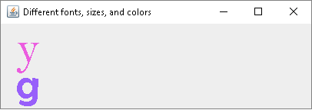



DrawCubes

**package** P1316;

**import** java.awt.Color;

**import** java.awt.Graphics;

**import** javax.swing.JPanel;

**import** java.awt.geom.GeneralPath;

**import** java.awt.Graphics2D;

**public** **class** DrawCubes **extends** JPanel

{

@Override

**public** **void** paintComponent(Graphics g)

{

**super**.paintComponent(g);

**this**.setBackground(Color.*WHITE*);

**int**[] xPoints = {50, 150, 150, 50, 50, 100, 200, 200, 100, 100};

**int**[] yPoints = {50, 50, 150, 150, 50, 100, 100, 200, 200, 100};

g.drawLine(50, 150, 100, 200);

g.drawLine(150, 50, 200, 100);

g.drawLine(150, 150, 200, 200);

Graphics2D g2d = (Graphics2D) g;

GeneralPath cube = **new** GeneralPath();

cube.moveTo(xPoints[0], yPoints[0]);

**for** (**int** count = 1; count < xPoints.length; count++)

cube.lineTo(xPoints[count], yPoints[count]);

cube.closePath();

g2d.draw(cube);

}

}

-------------------------------------------------

CubeMain

**package** P1316;

**import** java.awt.Color;

**import** javax.swing.JFrame;

**public** **class** CubeMain {

**public** **static** **void** main(String[] args) {

JFrame frame = **new** JFrame("Drawing a cube");

frame.setDefaultCloseOperation(JFrame.*EXIT_ON_CLOSE*);

DrawCubes rect = **new** DrawCubes();

frame.add(rect);

frame.setSize(315, 330);

frame.setVisible(**true**);

}

}

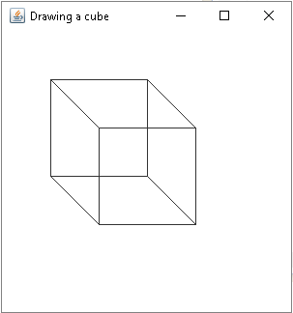

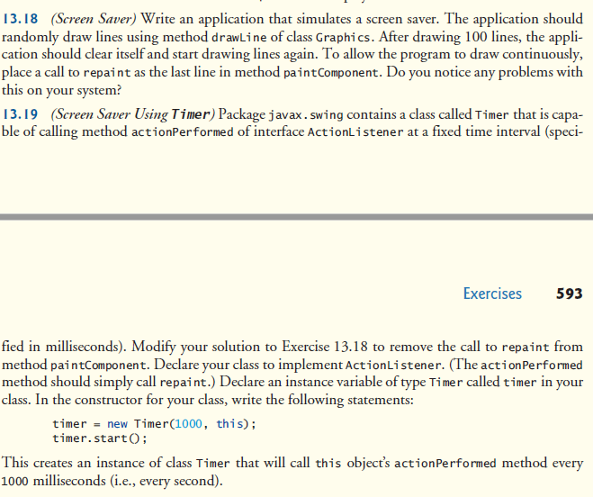

ScreenSaverFinal

**package** P1319;

**import** java.awt.Color;

**import** java.awt.Graphics;

**import** java.awt.event.ActionEvent;

**import** java.awt.event.ActionListener;

**import** javax.swing.JPanel;

**import** java.util.Random;

**import** javax.swing.Timer;

**public** **class** ScreenSaverFinal **extends** JPanel **implements** ActionListener

{

**private** Timer timer;

**public** ScreenSaverFinal()

{

timer = **new** Timer(1000, **this**);

timer.start();

}

**public** **void** paintComponent(Graphics g)

{

**super**.paintComponent(g);

Random rand = **new** Random();

**int** x1, x2, y1, y2;

**for**(**int** i=0; i < 100; i++)

{

x1 = rand.nextInt(300);

y1 = rand.nextInt(300);

x2 = rand.nextInt(300);

y2 = rand.nextInt(300);

g.setColor(**new** Color (rand.nextInt(256), rand.nextInt(256), rand.nextInt(256)));

g.drawLine(x1, y1, x2, y2);

}

}

**public** **void** actionPerformed(ActionEvent e)

{

repaint();

}

}

-------------------------------------------------

ScreenSaverMain

**package** P1319;

**import** java.awt.Color;

**import** javax.swing.JFrame;

**public** **class** ScreenSaverMain {

**public** **static** **void** main(String[] args) {

JFrame frame = **new** JFrame("Insane ScreenSaver");

frame.setDefaultCloseOperation(JFrame.*EXIT_ON_CLOSE*);

ScreenSaverFinal first = **new** ScreenSaverFinal();

frame.add(first);

frame.setSize(300, 300);

frame.setVisible(**true**);

}

}

